**CHAPTER-10 Class Room Objective**

**PAPER CUTTING**

In this chapter we shall study the problems relating to the analysis of pattern that is formed when a folded piece of paper have cut in a definite design.

**Problems on paper cutting:** In this type of questions, a set of three figures showing the manner in which a piece of paper has been folded, is given. In which of the first two figures, a dotted line together with an arrow indicates the direction of the folding. Thus, these two figures indicate the sequence in which the paper is folded. In the third figure there are marks showing the position and the nature of the cut made in the folded sheet. The examinee has to select one of the figure from the set of four alternative figures which would most closely resemble the pattern when the paper is unfolded.

**EX.1**

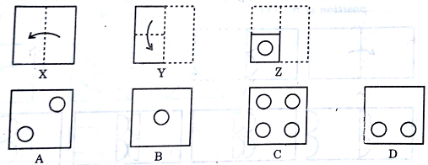

**EX.2**

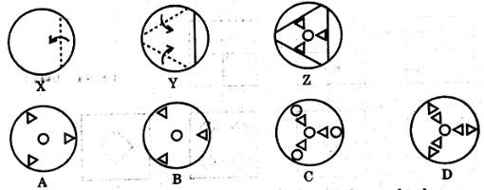

**EX.3**

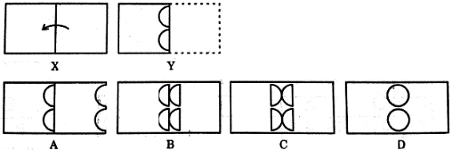

|  |
| --- |
| **EXCERCISE** |

**Q1.**

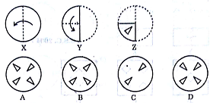

**Q2.**

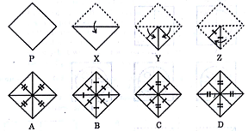

**Q3.**

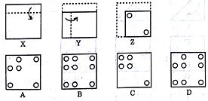

**Q4**

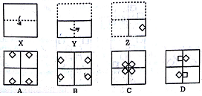

**Q5.**

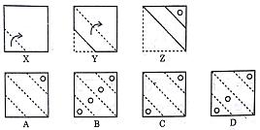

**Q6.**

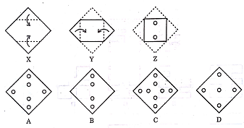

**Q7.**

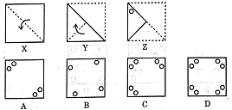

**Q8.**

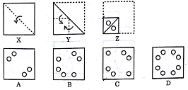

**Q9.**

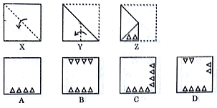

**Q10.**

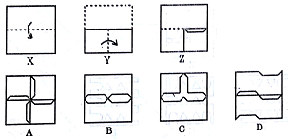

**Q11.**

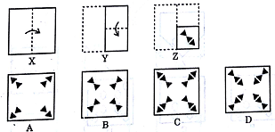

**Q12.**

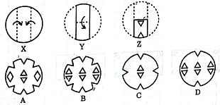

**Q13.**

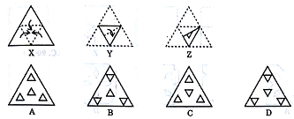

**Q14.**

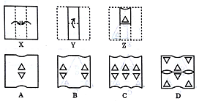

**Q15.**

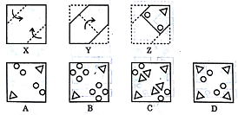

**Q16.**

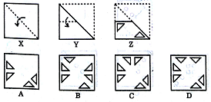

**Q17.**

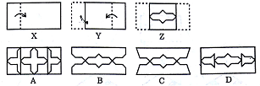

**Q18.**

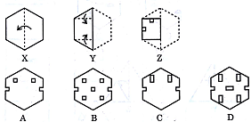

**Q19.**

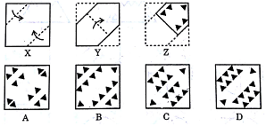

**Q20.**

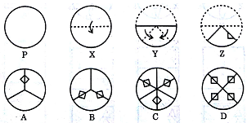

**Q21.**

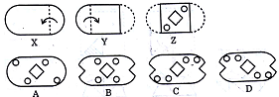

**Q22**.

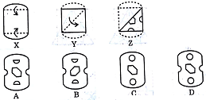

**Q23.**

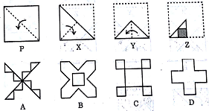

**Q24.**

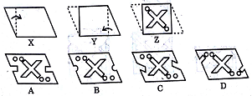

**Q25.**



